Thoughts from your President, Maxine Paul

What a busy and exciting month I’ve had – Apart from visiting some of the branches I dashed through during my “Summer of Hope” Challenge which is always a privilege, I was also privileged to represent CDMU, along with VP Rose, at the consecration of the new Bishop of Bradwell at Westminster Abbey and was invited to be part of his welcome service at Chelmsford Cathedral in November. There were conversations with Bishops Guli and Lynne and I joined Lucy Bubb in entertaining Sandy Becca, our overseas link from Jamaica and the Cayman Islands. Sandy brought us greetings from Jamaica and we sent greetings back and some “Transformation – Now!” bookmarks! Together we attended the branch meeting at St Barnabas, Hadleigh when the Late Queen’s Page, Paul Whybrew, gave a fascinating insight into the Queen’s life and routine without giving away any intimate secrets. He started at 16 and rose through the ranks in the Palace for 44 years. At one point looking after 10 corgis and latterly dutifully looking after the Queen herself right to the end. On the Sunday, we attended Choral Evensong at Chelmsford Cathedral and enjoyed an informative tour round afterwards with Eileen French followed by tea and biscuits. On Monday, we were off to Mary Sumner House for a fabulous tour of the House even ending up on the roof. Three things I would never have otherwise done – there are some wonderful perks to this role that God has entrusted to me. Thank you, Lord.
Another special event for me was being able to walk “The Labyrinth Under the Dome” at St Paul’s Cathedral. I don’t know if any of you have ever experienced a prayer labyrinth, but it can be such a peaceful, spirit-filled space to spend time with God. Thank you to Treasurer Tricia for arranging that for us to do together.
I hope to see many of you at the AGM and Service on 13th November. In the meantime, keep praying for each other and for our clergy especially Bishop Adam and the Archdeacons of Chelmsford and Stanstead as they begin their new ministries in Chelmsford Diocese.
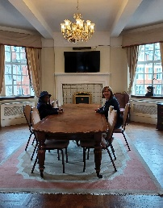
Love and blessings. Maxine x
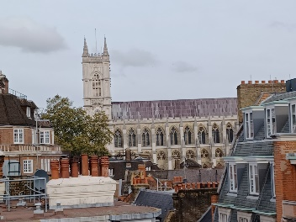
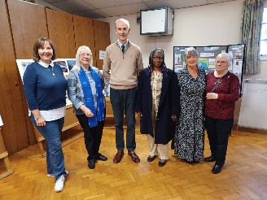
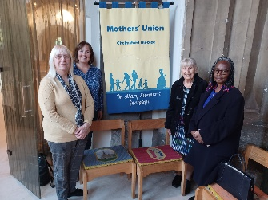
With “Tall Paul” at Chelmsford Cathedral Enjoying coffee Westminster Abbey
Hadleigh in the Queen from the roof of MSH
Elizabeth Room
Did you know that any member can drop into MSH and have a coffee in the Members’ Room (Queen Elizabeth Room)?

English for Women fundraising concert: Two Lads and a Laptop
Our first ever diocesan fundraising concert was held at Emmanuel Church Billericay on 7th October. It was a wonderful evening and has raised over £1000 for our diocesan project English for Women. Many thanks to Merrill and Pauline for organising this fundraiser.

AGM, Council and annual thanksgiving service – 13th November
Our AGM and Council meeting is scheduled for 13th November. Refreshments will be provided from 10am in the Cathedral followed by the annual thanksgiving service at 10:30am. The Bishop of Barking, Bishop Lynne Cullens will be leading the service followed by a talk afterwards in The Chapter House where we will stay for our AGM and Council where we will be voting on adoption of the updated diocesan constitution. We will also hear more about the 16 days of activism and RISE UP campaign. Tea and coffee will also be provided in the Chapter House. Please bring a packed lunch. Please let Secretary Kathryn know if you or any of your members are planning to attend. Please contact lynda.michael.booth@btinternet.com to order any certificates or badges for collection.

Clewer Initiative – Modern slavery and exploitation in nail salons
The Clewer Initiative have requested help with the development of a project related to modern day slavery and exploitation in nail salons. To help, members are asked to visit a nail salon and then complete an online survey about their experience. The survey is available at https://eu.surveymonkey.com/rGF3JL8F

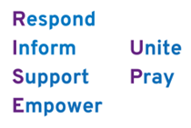
RISE UP campaign and 16 Days of Activism
The Annual Conference saw the launch of Mothers’ Union’s new campaign RISE UP. Maxine will be speaking about this at Council on 13th November and further information will be sent to all branch contacts in branch packs. Further information and resources can be found at https://www.mothersunion.org/riseup
The UN’s 16 Days of Activism against Gender-Based Violence will also be taking place between 25th November and 10th December. We will be sharing ideas and resources with members at Council and through branch packs as well as posting throughout the 16 Days on our website and Facebook page. Members are encouraged to mark the Global Day of Action on 25th November by holding a minute’s silence at 1:03pm in solidarity with the 1 in 3 women worldwide who experience abuse. We will be posting prayers and a 1 minute silence on our Facebook page on the 25th November at 1pm so do join us for this if you are able. We are also asking members to wear purple ribbons to symbolise their support for the campaign. Further information and resources can be found on the Mothers’ Union website mothersunion.org/MUGlobalDay or from Restored the Christian domestic abuse charity at https://www.restored-uk.org/ Please share with us any activities you are taking part in over the 16 Days so we can promote this more widely.

News from Mary Sumner House
- A new membership team has been created, led by Steph Nunn, as result of feedback for the reimagining agenda about what MSH needs to focus on to deliver the longevity and sustainability of MU. The team will focus on supporting growth in MU membership in branches and dioceses with resources and tools, including a new member pack and leaflets on the different ways people can get involved with MU.
- The Annual Gathering post-event link to resources includes Sheran’s inspirational speech, our Impact Video, Bishop Emma, our Central Chaplain’s “Building Bridges” session and all the prayers and worship from the day at https://mothersunionresourcehub.com/shared/81zioxm1 Click on the download icon next to each of the 7 resources (do not select download all, as the files are too big!)
- For regular updates on central MU work, sign up to the central e-newsletter on this link: https://mothersuniononline.org/p/1I8Y-G0K/sign-up-to-the-mothers-union-mailing-list
- The latest edition of “Connected” magazine should now have arrived and the Prayer Diary is expected mid-November. If any members have not received their copy then please contact Secretary Kathryn who will follow this up.

Dates for the dairy

- AGM and Council: 13th November, Chelmsford Cathedral
- MU Global Day of Action Saturday 25th November
- 16 Days of Activism – 25th November to 10th December

